***USBC MERCED COUNTY PRESENTS 2025 KING AND QUEEN TOURNAMENT***

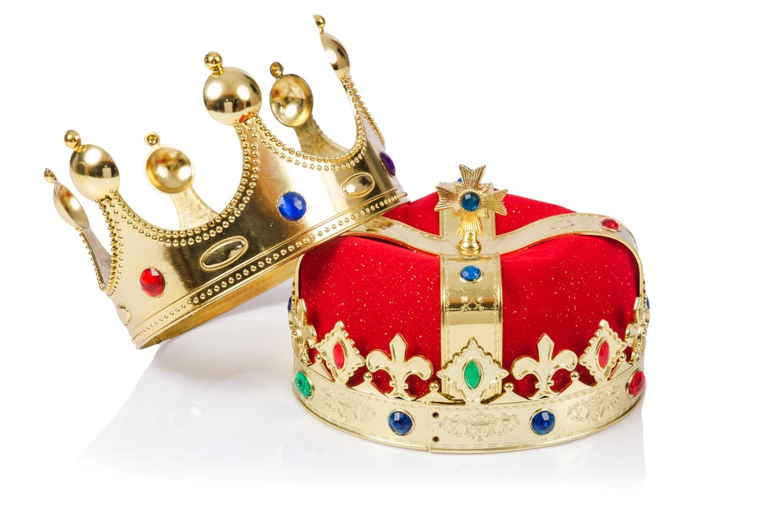

***COME JOIN US!***

***FEBRUARY 16TH, 2025 @ BELLEVUE BOWL***

***3 GAMES-HANDICAP 90% of 220*** ***$50.00 ENTRY***

**CHECK IN AT NOON. BOWL AT 1PM**

***BRACKETS WILL BE AVAILABLE***

***$ 13.50 LINAGE, $5 FEES, $31.50 PRIZE FUND***

***(Payout will be determined based on number of entries per Division)***

*TOP 4 MEN AND WOMEN QUALIFY FOR STEP LADDER FINALS*

***WINNER OF EACH DIVISION BOWL FOR ULTIMATE TITLE!***